
DEPARTMENT OF COMPUTER SCIENCE & TECHNOLOGY

Lab-1
HARSH MITTAL
2K19CSUN01082
CSE4B
Laboratory Objective: To implement Basic system calls of UNIX Operating System
Learning Outcome: Familiarity with the use of basic calls of UNIX

Course Outcome: CO2
Blooms Taxonomy: BT1, BT2, BT3
Write programs using the following system calls of UNIX operating system
- fork()
#include <stdio.h>
#include <sys/types.h>
#include <unistd.h>
int main()
{

fork();

printf("Hello world!\n");
return 0;

}

- exec()

#include <stdio.h>
#include <stdlib.h>
#include <unistd.h>
int main()
{

char *args[] = {"./EXEC", NULL};
execvp(args[0], args);

printf("Ending-----");

return 0;
}

- getpid()

#include <iostream>
#include <unistd.h>
using namespace std;

int main()
{
int pid;
pid = fork();
if (pid == 0)
{
cout << "\nParent Process id : "
<< getpid() << endl;
Scout << "\nChild Process with parent id : "
<< getppid() << endl;
}
return 0;
}

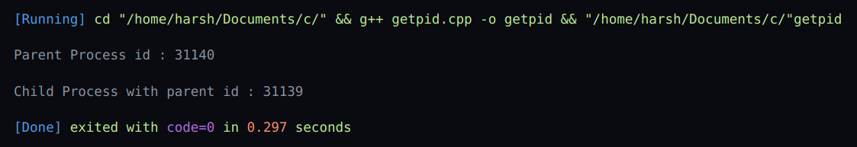
- exit()

#include <bits/stdc++.h>
using namespace std;

void fun(void)
{
cout << "Exiting";
}

int main()
{
atexit(fun);
exit(10);
}

- wait()

#include <stdio.h>
#include <stdlib.h>
#include <sys/wait.h>
#include <unistd.h>

int main()
{
pid_t cpid;
if (fork() == 0)
exit(0);
else
cpid = wait(NULL);
printf("Parent pid = %d\n", getpid());
printf("Child pid = %d\n", cpid);

return 0;
}

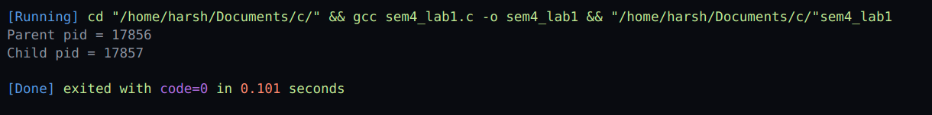

The exec system call is used to execute a file which is residing in an active process. When exec is called the previous executable file is replaced and new file is executed. More precisely, we can say that using exec system call will replace the old file or program from the process with a new file or program.

